1. 
2. This is what a Software Engineer does.
3. 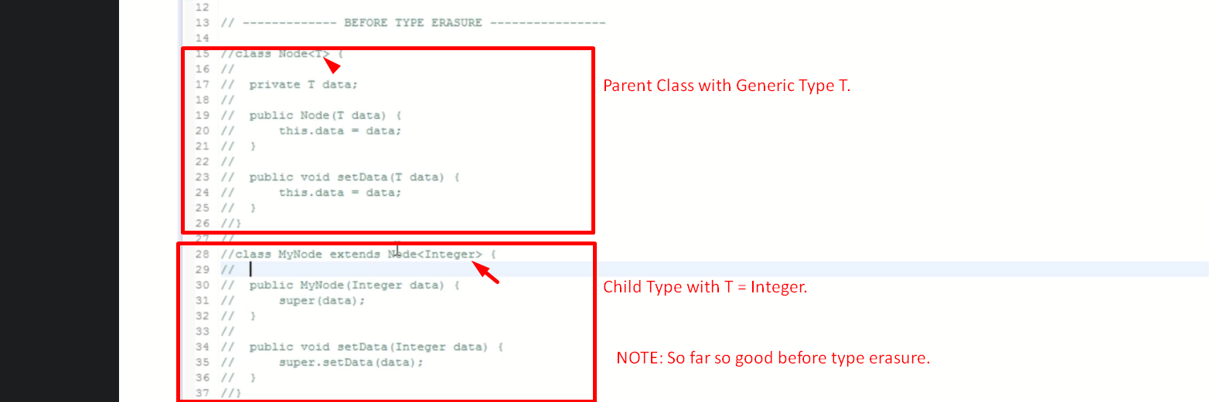
4. 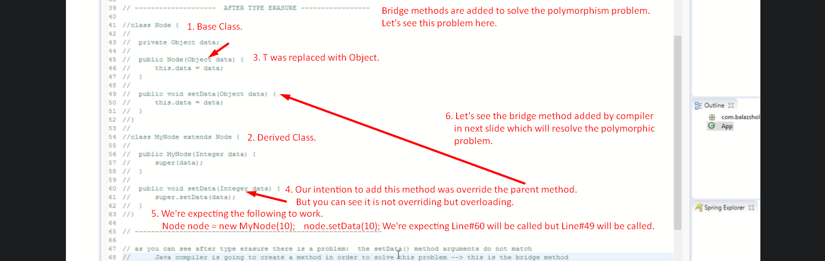
5. 